**METHODS TO BE USED IN OUR PROJECT**

**1) MNEMONIC:** With some remindful visuals knowledge is called back from the memory more easily. It’s a technique enhancing learning and and it is used t oto improve the memory. The target word is combined with an exaggerated visual.

**APPLICATION:** CRELLO / CANVA/SKETCHPAD/ PAINT/POSTERMYWALL

**CURRICULUM TOPIC**: HOBBIES /4th GRADE

**2) MIMING (Listen and Mime) :** Select the key words from a story and assign gestures to illustrate them. The students listen to the story and do the gestures as they hear.

**APPLICATION:** PADLET (Çekilen videolar yüklenecek)

**CURRICULUM TOPIC**: VERBS / 3rd&4th GRADEDS

[The Enormous Turnip - YouTube](https://www.youtube.com/watch?v=ysPxSHHE8Lg)

**3)ABC BRAINSTORMING :** An alphabetic list is prepared. The vocabulary of the target topic is provided writing a related word starting with each of the letter thus encouraging the students to come up with new words.

**APPLICATION:** POSTERMYWAL/ CANVA OR INTERACTIVE PDF

**CURRICULUM TOPIC**: JOBS /4th GRADE

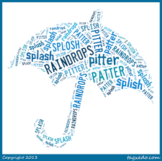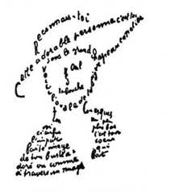**4)CALLIGRAMS:** A word or a piece of writing which is written to look like words’ meanings.

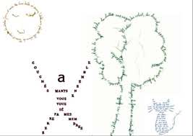 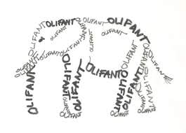

**APPLICATION:** WORD ART

**CURRICULUM TOPIC:** TRANSPORTATION / 3rd GRADE

**5)ROLE-PLAY:** Act the meaning in a role-play.

**APPLICATION:** AVATAR& CHATTER PIX& PIXTON

**CURRICULUM TOPIC:** DAILY ACTIVITIES /4th GRADE

**6)SNAP WORDS**: The meaningss of the target word are provided with entertaining drawings.

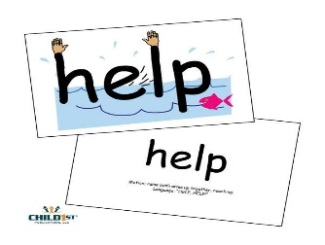

**APPLICATION:**POSTERMYWALL/CANVA/SKETCHPAD/PAINT/ STUDENTS’ OWN DRAWINGS

**CURRICULUM TOPIC**: ANIMAL FEATURES&NATURE/ 3rd GRADE (Extra words)

**7)LEARNING WITH ANTONYMS:**

**APPLICATION :** CRAM

**CURRICULUM TOPIC:**ADJECTIVES / 3rd&4th GRADES

**8)PICTURE BRAINSTORMING**: Show a picture related to one of the determined topics and ask the students to create a mind map producing related words to the picture.

**APPLICATION:** MINDMEISTER/ COGGLE

**CURRICULUM TOPIC**: IN MY CITY / 3rd GRADE

**9)MINIMAL PAIRS (Sounding Similar Words)**: Find links in spellings. Foot-food-fool, object-eject-reject-subject, sheep-ship

**APPLICATION:** LEARNING APPS

**CURRICULUM TOPIC:** ALL THE UNITS / 3rd&4th GRADES

**10) LYRICS TRAINING**: Learning language playing with the music videos and filling in the lyrics of your favourite songs.

**APPLICATION:** LEARNING APPS

**CURRICULUM TOPIC**: ALL THE UNITS / 4th GRADE